Beginner’s Guide to Building Claude Skills (from Anthropic Docs)

1. What is a Claude Skill?
A Claude Skill (also called an Agent Skill) is a modular capability that extends Claude’s functionality. Each Skill is a folder on Claude’s filesystem containing a SKILL.md file and optional resources (scripts, templates, etc.) that teach Claude how to perform a specific task. For example, Anthropic’s documentation notes that “Agent Skills are modular capabilities that extend Claude’s functionality. Each Skill packages instructions, metadata, and optional resources (scripts, templates) that Claude uses automatically when relevant”[1]. In practice, a Skill “is a directory containing a SKILL.md file” whose frontmatter and content guide Claude[2][1]. The Skills system loads these folders dynamically, giving Claude the domain-specific expertise it needs.

2. Why Use Skills?
Skills let you specialize Claude for domain-specific tasks and workflows. Instead of repeating the same instructions in every chat, you write them once in a Skill and Claude automatically applies them when relevant[3]. Key benefits include: - Tailored expertise: Skills give Claude reusable domain knowledge – “workflows, context, and best practices” – turning a general agent into a specialist[4]. For example, you can encode your company’s brand guidelines or data analysis procedures as a Skill. - Less repetition: Instructions in a Skill apply across conversations, so you don’t need to re-prompt Claude each time[3]. - Composable workflows: You can combine multiple Skills to handle complex tasks[3].
Typical use cases include having Claude apply corporate style guides to documents, follow organization-specific data pipelines, or automate routine personal tasks[5][4]. In short, Skills capture and reuse knowledge so Claude becomes faster, more consistent, and better at your specialized tasks.

3. Skill Anatomy
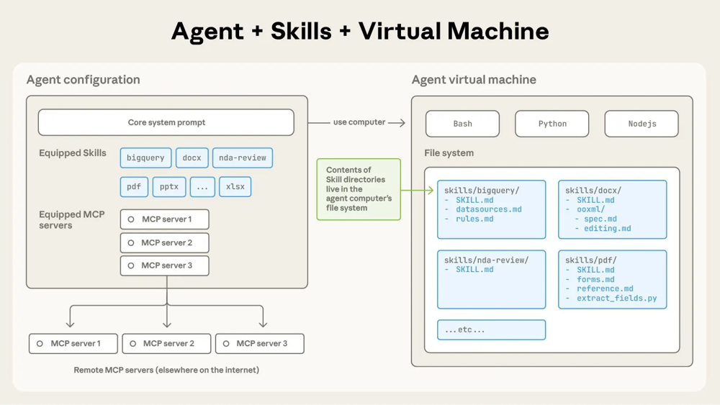
Figure: Example Skill folder layout (from Anthropic docs). Each Skill is a directory (e.g. pdf, docx) containing a SKILL.md file and any additional files. Each Skill is structured as follows: - The root folder is the Skill’s directory on Claude’s filesystem. Inside, there must be a file named SKILL.md plus any other files (helpers, templates, code) the Skill needs[6]. - SKILL.md structure: This file begins with YAML frontmatter including at least name and description fields[6]. For example, the PDF skill uses name: pdf-processing with a description of extracting text and tables[7]. After the frontmatter, the rest of SKILL.md contains markdown sections (e.g. # PDF Processing, ## Quick start) with clear, step-by-step instructions and examples[8]. - Additional files: You can bundle other files in the Skill folder and reference them from SKILL.md. These might be markdown docs with more guidance or templates. For instance, Anthropic’s PDF skill has FORMS.md and REFERENCE.md in its folder for detailed instructions[9]. - Tools (executable code): Skills can include scripts (e.g. Python) in a scripts/ subfolder. Claude treats these as tools it can run. For example, the PDF skill’s scripts/fill_form.py is a Python tool that Claude executes to extract PDF form fields[9][10]. Because Claude executes the code, the script’s contents do not count against context limits[10][11]. - (Actions/config): Detail missing from official docs: Anthropic’s public documentation does not explicitly describe any “actions” or special configuration fields in a skill’s metadata.

4. Step-by-Step: Build Your First Skill
There are two main ways to create a Skill: via Claude.ai conversation (using the skill-creator) or manually by writing files.
Via Claude.ai (conversation): Anthropic provides a built-in skill-creator Skill that guides you interactively through natural language. The basic process is: 1. Enable skill-creator: In Claude.ai go to Settings > Capabilities > Skills and turn on “skill-creator”[12]. 2. Describe your new Skill: Start a new chat and tell Claude what you want, for example “I need a skill for quarterly business reports.” Upload any relevant templates or examples you have (company reports, brand guidelines, etc.)[13]. 3. Answer questions: Claude will ask clarifying questions about your workflow (e.g. “When would you use this?”, “What makes the output good?”). Provide concrete details and examples as if explaining to a colleague[14]. 4. Claude generates the Skill: As you answer, Claude writes a SKILL.md file with the appropriate YAML and instructions. It organizes your inputs (instructions, templates, etc.) and even generates any needed code tools. Claude then packages everything into a ZIP file[15]. 5. Activate and test: Download the ZIP file and upload it under Settings > Capabilities > Skills in Claude.ai[16]. Your skill is now active. Test it by giving Claude a prompt that should trigger it (you should see “Using [skill name]” in Claude’s reasoning). If needed, continue the conversation to refine the instructions and re-download the updated Skill.
Manual / CLI-based setup: You can also build a Skill directly by writing the files: - Create the folder and SKILL.md: Manually make a directory for your skill. Inside, create SKILL.md starting with YAML frontmatter (name, description) and add your instruction sections[6]. - Add files and code: Place any needed reference docs or code in the same folder (for example, add a scripts/ subfolder with helper scripts). - Install or upload: In Claude Code, simply place the skill directory in ~/.claude/skills and Claude Code will load it automatically[17]. For the Claude API, zip the skill folder and use the /v1/skills endpoint to upload it (providing versioning and management)[18]. In Claude.ai, upload the zip under Settings as above.
If you prefer, see the Agent Skills Cookbook for more examples (anthropic’s GitHub) and the official docs guide for the YAML schema and best practices.

5. Governance, Testing & Safety
Because Skills give Claude the ability to run code and access resources, follow strict safety and testing practices: - Use trusted sources: Only use or install Skills that you (or your organization) created or that come from Anthropic. Malicious Skills could make Claude execute harmful commands or leak data. Anthropic warns “only use Skills from trusted sources” and recommends thoroughly auditing every file in a Skill[19][20]. - Understand risks: Anthropic highlights risks like prompt injection or data exfiltration via Skills[21]. Treat skill files like installing software: check for unexpected network calls, file access, or scripts doing more than stated[19][20]. - Test thoroughly: After adding a Skill, test it with representative prompts to ensure Claude uses it correctly. Claude’s docs advise: “test it with a few different prompts to ensure it works as expected”[22]. Organize one Skill per purpose to simplify testing. - Environment constraints: Claude’s Skills run in a sandboxed VM. Sessions have no data persistence beyond the conversation[23]. However, Skills run in the code execution environment, which (depending on product) may allow or disallow network access and only pre-installed packages[24]. Plan your Skill knowing these limits (e.g. API Skills cannot call external services). - Enterprise governance: On Team/Enterprise plans, Skills must be enabled by an admin at the org level before anyone can use them[25]. Also note that Skills in Claude.ai are per-user (each team member must upload separately)[26].

6. Example Skill: PDF Processing
A concrete example is Anthropic’s built-in PDF Processing skill. Its SKILL.md frontmatter uses name: pdf-processing and describes tasks like extracting text or filling forms from PDFs[7]. Inside the file, there are sections like # PDF Processing and ## Quick start with step-by-step guidance. For instance, it includes Python code examples (“Use pdfplumber to extract text from PDFs”)[8]. The skill’s folder (named pdf-skill/ in the docs) contains:
pdf-skill/
├── SKILL.md (instructions and metadata)
├── FORMS.md (form-filling guidance)
├── REFERENCE.md (detailed reference)
└── scripts/
└── fill_form.py (Python script to extract form fields)
Claude will only load the parts of this skill as needed (e.g. reading FORMS.md when filling forms). It can also execute the fill_form.py script via bash to process PDFs efficiently[9][10]. This example shows how Skills combine instructions and code to extend Claude’s abilities in a practical way.
Sources: Official Anthropic documentation and GitHub: Claude Docs (Agent Skills)[1][6][7][8]; Anthropic Engineering blog[2][11]; Claude Help Center (Claude.ai) articles[20][13]; Anthropic GitHub (example skills)[5][9].

[1] [3] [4] [6] [7] [8] [9] [10] [19] [24] [26] Agent Skills - Claude Docs
https://docs.claude.com/en/docs/agents-and-tools/agent-skills/overview
[2] [11] Equipping agents for the real world with Agent Skills \ Anthropic
https://www.anthropic.com/engineering/equipping-agents-for-the-real-world-with-agent-skills
[5] GitHub - anthropics/skills: Public repository for Skills
https://github.com/anthropics/skills
[12] [13] [14] [15] [16] How to create a skill with Claude through conversation | Claude Help Center
https://support.claude.com/en/articles/12599426-how-to-create-a-skill-with-claude-through-conversation
[17] [18] [25] Introducing Agent Skills | Claude
https://www.claude.com/blog/skills
[20] [21] [22] [23] Using Skills in Claude | Claude Help Center
https://support.claude.com/en/articles/12512180-using-skills-in-claude

